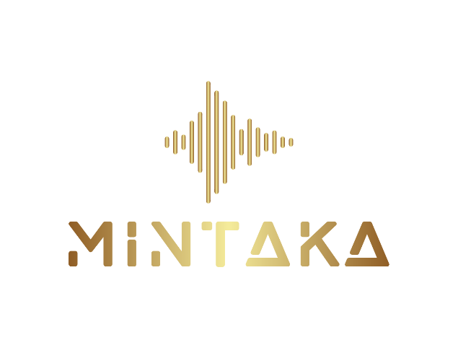

**New Client Form**

**Basic Information**

|  |  |
| --- | --- |
| Name |  |
| Phone number |  |
| Email address: |  |
| What are the main reasons for coming for an Acutonics ® session today? |  |

About ACUTONICS

Acutonics ® is a non-invasive methodology that draws on Oriental medicine, and incorporates

the use of sound vibration. In an Acutonics session specific vibratory energy is created

through precision-calibrated tuning forks, hand chimes, and planetary gongs.

The Acutonics Institute of Integrative Medicine, created this modality, and I have studied

with the institute and incorporate it into my clinical practice. The institute believes in the

creation of partnerships between practitioner and patient and in finding the right balance

between conventional and alternative health care models that facilitate the body’s innate

wisdom to heal. In the course of your session specific tuning forks, and other sound based

tools may be selected based on the information that has been provided. A treatment plan

will be reviewed with you prior to the session.

It is important for you to understand that Acutonics does not cure, treat, or diagnose specific

medical conditions. This methodology is complementary, therapeutic and integrative. It

promotes wellness, balance and wellbeing.

By signing below, I acknowledge the following:

• I have honestly and comprehensively answered the above questions.

• It is my responsibility to notify my practitioner if any information provided here changes

• If at anytime during the session I feel uncomfortable I will inform my practitioner immediately

• I recognize and understand my responsibilities as a client

• By voluntarily signing below, I consent to the performance of an Acutonics session by

the Acutonics practitioner named below. I have discussed a session plan with my

Acutonics practitioner and had the opportunity to ask questions.

I intend this consent form to cover the entire series of sessions for which I may visit this

practitioner.

|  |  |
| --- | --- |
| Print Name of the Client |  |
| (If Client is Under 18, Print Name of Guardian) |  |
| Signature (type name if digitally submitted) |  |
| Date |  |

Please email the filled form to

[**acutonics@mintaka-wellness.com**](mailto:acutonics@mintaka-wellness.com)